34th Annual Disability Awareness Day
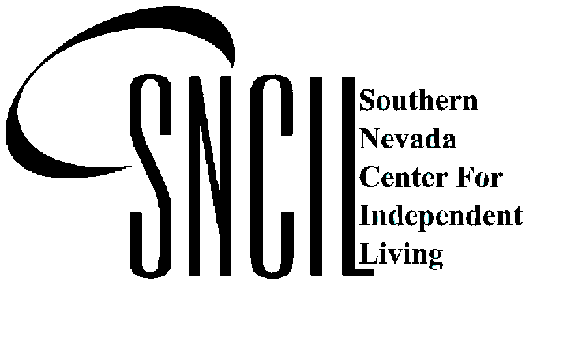
October 25, 2025
Sammy Davis Jr. Festival Plaza at Lorenzi Park
10:00 a.m. - 2:00 p.m.

Cosponsored by Southern Nevada Center for Independent Living (SNCIL), City of Las Vegas, Nevada; and The Challenger.

APPLICATION

The Undersigned Applicant hereby requests permission to enter the Southern Nevada Center for Independent Living (SNCIL) 34th Annual Disability Awareness Day, which is scheduled for October 25, 2025 at Sammy Davis Jr. Festival Plaza at Lorenzi Park 720 Twin Lakes Drive, Las Vegas, NV 89107. The hours of the event will be 10:00 a.m. to 2:00 p.m. The Applicant is responsible for booth set up, decorations, etc. SNCIL reserves the right to refuse applicants participation in the event if the proposed activity or if the materials do not fit the event theme or quality standards. Limit 30 Vendors.

Please print:
COMPANY NAME ________________________________ CONTACT _____________________________

ADDRESS ____________________________ CITY _____________ STATE ____________ ZIP _________

PHONE ___________________ FAX _________________ E-MAIL_________________________________

FEE for SPACE: $50.00 donation for nonprofit organizations
$90.00 donation for profit organizations
Table Space, 5' and two chairs

Please make check payable to: Southern Nevada Center for Independent Living
Cancellation Policy: 2 weeks’ notice required for a refund.

___________$50.00 non-profit organizations ___________$90.00 for profit organizations

AMOUNT OF FEES INCLUDED WITH APPLICATION: $________ Check # ______

Need Electricity? Yes or No (Please Circle)

Provide a brief description of materials to be displayed:
_______________________________________________________________________________________
_______________________________________________________________________________________
_______________________________________________________________________________________

MAIL APPLICATION TO: Southern Nevada Center for Independent Living
2950 S. Rainbow Blvd., Suite 220
Las Vegas, Nevada 89146
Fax or Call with any questions: Fax - 702-889-4574
Phone - 702-889-4216

SNCIL 34th Annual Disability Awareness Day - October 25, 2025

GENERAL RULES AND REGULATIONS:

- Masks according to the CDC or Governor’s Guidance by Vendors and Attendees

- Applicants may only display items listed in the application and approved by SNCIL. If an applicant wishes to display additional items(s), SNCIL approval is required.

2. Applicant must have a resale tax permit and all other appropriate licenses and permit required by the city, County and State.

3. Setup time at 8:00 a.m. unless otherwise arranged. Applicants must be ready to display no later than 10:00 a.m. Tear down will not be permitted until the close of the event at 2:00 p.m.

- Applicant is required to remove all trash and other articles from his/her booth area at the close of the day.

5. Southern Nevada Center for Independent Living has the right to refuse applicant participation in the event if the applicant proposed activity or product does not fit the theme or quality standards of the event.

6. Applicant is requested to contact SNCIL two weeks prior to the event if he/she will not be able to attend.

I have read and understand the rules and regulations listed herein and agree to comply.

_________________________________ _______________________________
Applicant (s) Signature Date

_________________________________
Organization/Company Name

SNCIL 34th Annual Disability Awareness Day - October 25, 2025

HOLD HARMLESS AGREEMENT:

Please Select Private Entity or Political Subdivisions

Private Entity

[ ] In consideration of Southern Nevada Center for Independent Livings (SNCIL):
Acceptance of the application to participate in 34th Annual Disability Awareness Day, October 25, 2025 the applicants (its officers, directors, agents, employees, representatives and / or members) agree to indemnify, hold harmless, protect and defend SNCIL, Las Vegas, Nevada and the City of Las Vegas, Nevada Recreation Department, as well as each entities agent, entities agents, employees, and/or representatives, from and against any loss, claim of loss, injury (including, but not limited to, personal injury), damage (including, but not limited to, property damage), liability or other expense (including, but not limited to, reasonable attorneys fees and court costs), claimed by or resulting from a third party or the applicant (or any officer, director, agent, employee, representative of the applicant), that arises out of, or is any manner related to, any act failure to act by the applicant (its officers, directors, agent, employees, representatives, and/or members) in connection with the applicants participation in this event.

Political Subdivisions.

[ ] Subject to the limitations of law, and to the extent allowed by law, each involved party and/or entity shall be responsible for the acts or omissions—negligent or intentional—of its officers, directors, agents, representatives, members and/or employees in connection with participation in the SNCIL 34th Annual Disability Awareness Day. Neither party nor entity waives any rights of defenses to indemnification that may exist under law. Except as otherwise provided for by law, the rights and remedies of the parties/entities shall not be exclusive and are in addition to any other rights and remedies provided by law or equity, including, but not limited to, actual damages. Further, each party or entity shall be responsible for its own attorney’s fees. Finally, Clark County Social Service does not waive and intends to assert, as applicable, all available NRS Chapter 41 liability limitations in all cases.

The undersigned has read this agreement carefully and represents that he or she has the authority to execute this agreement on behalf of the party for whom he or she is signing.

______________________________ _____________________________
Print Applicant(s) Name Date

_______________________________ _____________________________
Applicant (s) Signature Organizations/Company Name

Please keep a copy for your Agency, and thank you for sharing your information, services etc. with individuals of all disabilities.

